***NAME : Himanshu Dixit***

***ENROLL NO. : B64178***

***BATCH : B10***

***Software Development Fundamentals – I(15B11CI111)***

***ODD 2021***

***Tutorial Sheet – 9***

***1.*** *Define a structure named distance with two integer members feet and inches. Read 4 distances from the user and print all four distances in the increasing order. Write a function to find the sum of all four distances.*

***Solution:***

#include<stdio.h>

struct distance

{

int inches;

int feet;

};

void sum(struct distance s[])

{

int sumf=0;

int sumi=0;

for(int i=0;i<4;i++)

{

sumf=sumf+s[i].feet;

sumi=sumi+s[i].inches;

}

if(sumi>=12)

{

int a=sumi/12;

sumi=sumi%12;

sumf=sumf+a;

}

printf("\nsum of distance = %d.%d",sumf,sumi);

}

int main()

{

struct distance d[4];

int k;

for(int i=0;i<4;i++)

{

printf("enter distance %d in feet and inches ",i+1);

scanf("%d %d",&d[i].feet,&d[i].inches);

if(d[i].inches>=12)

{

int a=d[i].inches/12;

d[i].inches=d[i].inches%12;

d[i].feet=d[i].feet+a;

}

}

printf("\n");

for(int i=0;i<4;i++)

{

for(int j=i+1;j<4;j++)

{

if(d[i].feet > d[j].feet)

{

k=d[i].feet;

d[i].feet=d[j].feet;

d[j].feet=k;

k=d[i].inches;

d[i].inches=d[j].inches;

d[j].inches=k;

}

else if(d[i].feet == d[j].feet)

{

if(d[i].inches > d[j].inches)

{

k=d[i].inches;

d[i].inches=d[j].inches;

d[j].inches=k;

k=d[i].feet;

d[i].feet=d[j].feet;

d[j].feet=k;

}

}

}

}

for(int i=0;i<4;i++)

{

printf("%d.%d ",d[i].feet,d[i].inches);

}

sum(d);

return 0;

}

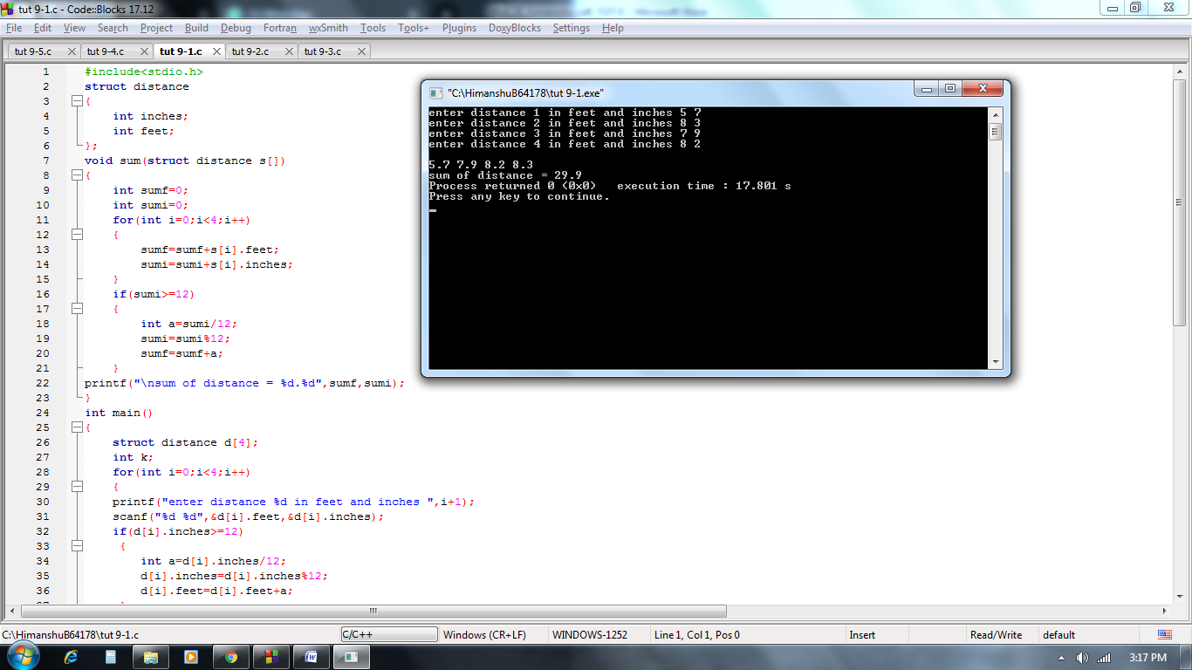

***2.*** *Enter the marks of 4 students in Chemistry, Mathematics and Physics (each out of 100) using a structure named Marks having elements roll_no, name, chem_marks, maths_marks and phy_marks and then display the percentage and highest marks of each student.*

*Input:  rollno 1*

*Name: Abha*

*Physics: 65*

*Maths: 75*

*Chemistry: 50*

*Output: percentage of  Abha is 63.3 and highest marks is 75.*

***Solution:***

#include<stdio.h>

struct student

{

int rollno;

char name[50];

int phy_marks;

int maths_marks;

int chem_marks;

float per;

};

int main()

{

struct student s[4];

for(int i=0;i<4;i++)

{

int max;

printf("Enter student roll no. ");

scanf("%d",&s[i].rollno);

printf("Enter student name ");

scanf("%s",s[i].name);

printf("Enter student physics marks ");

scanf("%d",&s[i].phy_marks);

printf("Enter student maths marks ");

scanf("%d",&s[i].maths_marks);

printf("Enter student chemistry marks ");

scanf("%d",&s[i].chem_marks);

s[i].per=(s[i].phy_marks+s[i].maths_marks+s[i].chem_marks)/3.00;

if(s[i].phy_marks >= s[i].maths_marks && s[i].phy_marks >= s[i].chem_marks)

max=s[i].phy_marks;

else if(s[i].maths_marks >= s[i].phy_marks && s[i].maths_marks >= s[i].chem_marks)

max=s[i].maths_marks;

else

max=s[i].chem_marks;

printf("percentage of %s is %f and highest marks is %d\n\n",s[i].name,s[i].per,max);

}

}

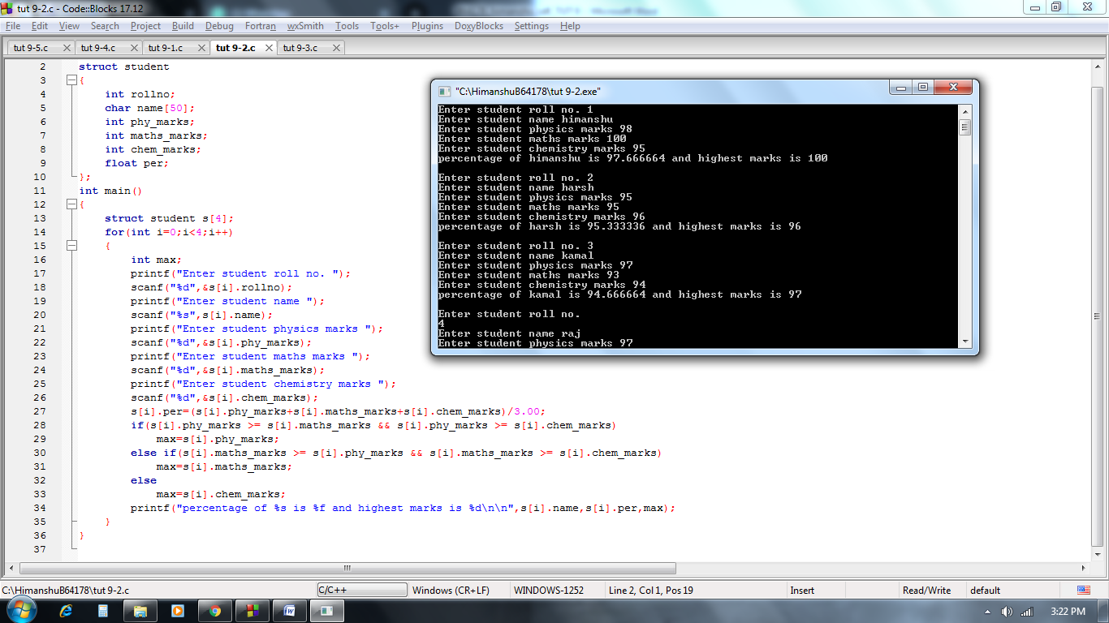

***3.*** *Write a program to Calculate Difference between Two Time Periods using structure. Structure named Time having three integer data members i.e. hours, minutes and seconds.There are two variables of time : start and stop.*

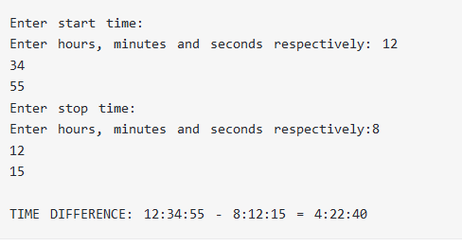

***Solution:***

#include<stdio.h>

struct time

{

int hrs;

int min;

int sec;

}start,stop,diff;

int main()

{

printf("Enter the start time in hours:minutes:sec format\n");

scanf("%d%d%d",&start.hrs,&start.min,&start.sec);

printf("Enter the stop time in hours:minutes:sec format\n");

scanf("%d%d%d",&stop.hrs,&stop.min,&stop.sec);

diff.sec=start.sec-stop.sec;

diff.min=start.min-stop.min;

diff.hrs=start.hrs-stop.hrs;

while(diff.sec<0)

{

diff.sec=diff.sec+60;

diff.min--;

}

while(diff.sec>60)

{

diff.sec=diff.sec-60;

diff.min++;

}

while(diff.min<0)

{

diff.min=diff.min+60;

diff.hrs--;

}

while(diff.min>60)

{

diff.min=diff.min-60;

diff.hrs++;

}

if(diff.hrs<0)

printf("invalid difference");

else

printf("TIME DIFFERENCE: %d:%d:%d - %d:%d:%d = %d:%d:%d",start.hrs,start.min,start.sec,stop.hrs,stop.min,stop.sec,diff.hrs,diff.min,diff.sec);

return 0;

}

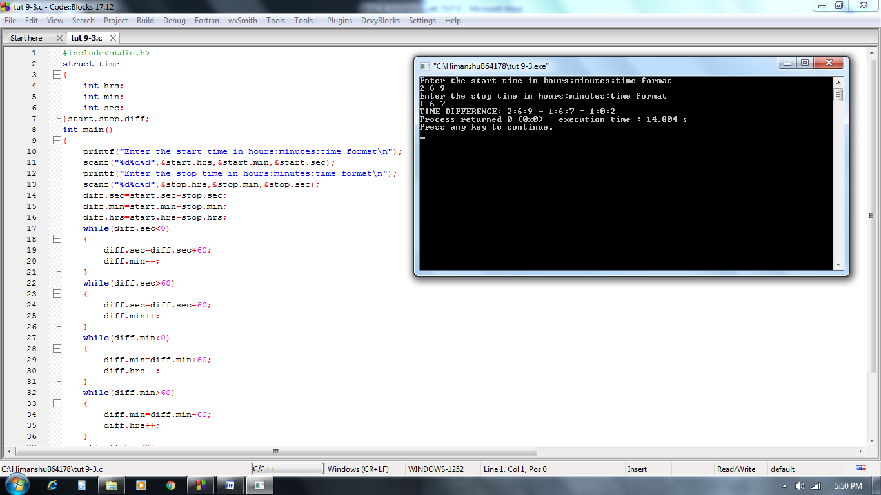

***4.*** *Write a structure to store the name, account number and balance of customers(more than 10) and store their information.*

*i. Write a function to add Rs.100 in the balance of all the customers having more than Rs.1000 in their balance and then print the incremented value of their balance.*

*ii- Write a function to display the detail of any account number entered by user.*

*iii. Write a function to display withdraw some amount entered by user and then display the balance amount.*

***Solution:***

#include<stdio.h>

struct customer{

char name[50];

long int acc_no;

float balance;

};

void updatebalance(struct customer c1[] ,int n)

{

for(int i=0;i<n;i++)

{

if(c1[i].balance>1000)

{

c1[i].balance=c1[i].balance+100;

printf("\nname : ");

puts(c1[i].name);

printf("account number : %d",c1[i].acc_no);

printf("\nbalance : %f",c1[i].balance);

}

}

}

void displaydetails(struct customer c1[] ,int n)

{

long int ac;

printf("\nEnter acount number whome which you want to print the details : ");

scanf("%d",&ac);

for(int i=0;i<n;i++)

{

if(c1[i].acc_no==ac)

{

printf("\nname : ");

puts(c1[i].name);

printf("account number : %d",c1[i].acc_no);

printf("\nbalance : %f",c1[i].balance);

}

}

}

void withdraw(struct customer c1[] ,int n)

{

long int ac;

float wd;

printf("\nEnter acount number who wants to withdraw the amount : ");

scanf("%d",&ac);

for(int i=0;i<n;i++)

{

if(c1[i].acc_no==ac)

{

printf("Enter the withdarw amount : ");

scanf("%f",&wd);

c1[i].balance=c1[i].balance-wd;

printf("withdraw money is : %f",wd);

printf("\nbalance amount is : %f",c1[i].balance);

}

}

}

int main()

{

int n;

struct customer c[50];

printf("Enter number of customer : ");

scanf("%d",&n);

for(int i=0;i<n;i++)

{

printf("Enter %dst customer details\n",i+1);

scanf("%s",c[i].name);

fflush(stdin);

scanf("%d",&c[i].acc_no);

scanf("%f",&c[i].balance);

}

updatebalance(c,n);

displaydetails(c,n);

withdraw(c,n);

return 0;

}

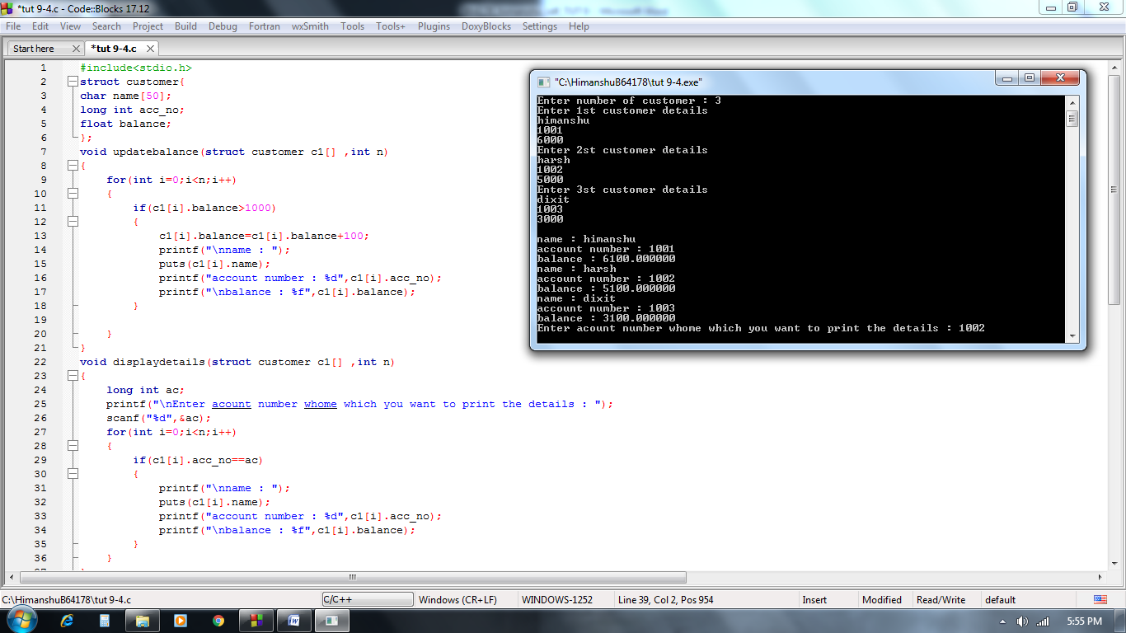

***5.*** *Create a structure to store the employee_id, employee_name, designation (ProjectManager, Team Lead, and Team Member), years_of_experience and salary of the employees(at least 5 records).*

*Write a function to add a bonus of 5,000 to the salary of employees having 5 or more years_of_experience and print emp_id and salary of the updated records.*

***Solution:***

#include<stdio.h>

struct employee {

int id;

char name[30];

char designation[50];

int y_of_exp;

float salary;

};

void bonus(struct employee e1[])

{

for(int i=0;i<5;i++)

{

if(e1[i].y_of_exp>=5)

{

e1[i].salary=e1[i].salary+5000;

printf("employee id = %d\n",e1[i].id);

printf("salary = %.2f\n",e1[i].salary);

}

}

}

int main()

{

struct employee e[10];

for(int i=0;i<5;i++)

{

printf("Enter the %d empoyees details :\n",i+1);

printf("emp id : ");

scanf("%d",&e[i].id);

printf("name : ");

fflush(stdin);

gets(e[i].name);

printf("designation : ");

gets(e[i].designation);

printf("year of experience : ");

scanf("%d",&e[i].y_of_exp);

printf("salary : ");

scanf("%f",&e[i].salary);

printf("\n");

}

bonus(e);

return 0;

}

